# [FUEL THEFT DETECTION SYSTEM]

**A report submitted in partial fulfillment of the Academic requirements for the award of the degree of**

**Bachelor of Technology**

Submitted by

**B.NAGARAJU (21H51A0428)**

**K.MOUNITHA (21H51A0433)**

**MD.MUNEEB (21H51A0436)**

**G.NITIN (21H51A0438)**

**B.MOUNITHA (21H51A0459)**

**UNDER THE COURSE INTRODUCTION TO SOCIAL INNOVATION**



**CENTRE FOR ENGINEERING EDUCATION RESEARCH**

**CMR COLLEGE OF ENGINEERING & TECHNOLOGY**

**(Autonomous)**

**(NAAC Accredited with ‘A+’ Grade & NBA Accredited) (Approved by AICTE, Permanently Affiliated to JNTU Hyderabad) KANDLAKOYA, MEDCHAL ROAD, HYDERABAD-501401**

**2021-22**



# CENTRE FOR ENGINEERING EDUCATION RESEARCH

**CMR COLLEGE OF ENGINEERING & TECHNOLOGY**

# (Autonomous)

**(NAAC Accredited with ‘A+’ Grade & NBA Accredited) (Approved by AICTE, Permanently Affiliated to JNTU Hyderabad) KANDLAKOYA, MEDCHAL ROAD, HYDERABAD-501401**



# CERTIFICATE

This is to certify that the report entitled **“FUEL THEFT DETECTION SYSTEM”** is a bonafide work done by **B.NAGARAJU (21H51A0428), K.MOUNITHA(21H51A0433), MD.MUNEEB (21H51A0536), G.NITIN (21H51A0438), B.RAJITHA (21H51A0459)** of I

B.Tech, in partial fulfillment of the requirements for the award of the degree of Bachelor of Technology, submitted to Centre for Engineering Education Research, CMR College of Engineering & Technology, Hyderabad during the Academic Year 2021-22.

**(Names of the Project Coordinators)**

**Mr.G.KARTHIK REDDY (Asst.Professor) (CHEER HOD)**

**Mrs.SHILPARANI H R (Asst.Professor) Mr.B.SURESH RAM Mr.S.SURESH (Asst.Professor) (Asst.Professor)**



# DECLARATION

We, the students of I B. Tech of Centre for Engineering Education Research, **CMR COLLEGE OF ENGINEERING & TECHNOLOGY**, Kandlakoya, Hyderabad, hereby declare, that under the supervision of our course coordinators, we have independently carried out the project titled “**FUEL THEFT DETECTION SYSTEM**” and submitted the report in partial fulfillment of the requirement for the award of Bachelor of Technology in by the Jawaharlal Nehru Technological University, Hyderabad (JNTUH) during the academic year 2021-2022.

|  |  |  |
| --- | --- | --- |
| **NAME** | **ROLL NUMBER** | **SIGNATURE** |
| **B.NAGARAJU** | **21H51A0428** |  |
| **K.MOUNITHA** | **21H51A0433** |  |
| **MD.MUNEEB** | **21H51A0436** |  |
| **G.NITIN** | **21H51A0438** |  |
| **B.RAJITHA** | **21H51A0459** |  |



# ACKNOWLEDGEMENT

We are obliged and grateful to thank **Mr.B.SURESH RAM**, HOD (CEER), CMRCET, for his cooperation in all respects during the course.

We would like to thank the Principal of CMRCET, **Dr.V.A. NARAYANA**, for his support in the course of this project work.

We would like to thank my Project coordinators **Mr.G.KARTHIK REDDY** Asst. Professor, CEER, **Mrs.SHILPARANI H R** Asst. professor and **Mr.S.SURESH** Asst.professor CEER for his/her guidance to complete my project work.

Finally, we thank all our faculty members and Lab Assistants for their valuable support.

We own all our success to our beloved parents, whose vision, love and inspiration has made us reach out for these glories.



# TABLE OF CONTENTS

|  |  |  |  |
| --- | --- | --- | --- |
| **CHAPTERS** | | **DESCRIPTION** | **PAGE No** |
|  |  | Abstract | 6 |
| 1 |  | Introduction | 7 |
|  | 1.1 | Problems identified | 8 |
|  | 1.2 | Root cause of the problem | 8 |
| 2 |  | Literature Review | 9 |
| 3 |  | Methodology | 10 |
|  | 3.1 | Problem Statement | 11 |
|  | 3.2 | Objective | 11 |
|  | 3.3 | Requirement Analysis | 11 |
|  | 3.4 | Block Diagram | 12 |
|  | 3.5 | Design Description | 13 |
| 4 |  | Results and Discussions | 14 |
| 5 |  | Conclusions | 15 |
|  |  | References | 15 |



**ABSTRACT**

The primary design goal is to design a system capable of monitoring the fuel information in real time whenever we visit petrol bunks to fill our vehicles. Whenever we visit bunks to fill tanks of our vehicles, they do fiddle while filling from dispensers since they coded it internally with some digital error coding technique, which dispenses less amount of petrol and show correct amount on the display of the dispenser. These frauds are being taking place now-a-days in many bunks across the big cities and even small towns. Another problem is fuel thefts when we park our vehicles at some place. Some people remove petrol pipe of vehicle and do some other techniques to steal petrol from vehicles. Today’s world needs digital techniques for measurement of any quantity conventional like real time fuel monitoring and theft detection system using IOT. Our proposed work we show the amount of fuel Present in fuel tank digitally with flow sensor. The fuel while its getting dispensed from dispenser in fuel stations and monitor lively to caught them if they try to make fraud. Also fuel theft is major problem in society. In our project we implemented if fuel gets theft then alert will be send to owner of vehicles also buzzer makes noise so that owner of vehicles, someone like watchmen or incharge of parking area get aware and take action. In traditional vehicle system such kind of system is not implemented like display fuel availability digitally, fuel dispensed from dispenser in bunks cannot be measured & fuel Theft from vehicles cannot be avoided. The proposed system integrated software Arduino IDE and firebase for Database purposes and an android application to see all the details. This system offers an theft detection System in addition to manual monitoring of fuel. This system measures fuel volume and sends measured volume to the owner’s mobile as well as cloud through network. It also provides a technique for detecting theft or fraud incidents in case of fuel theft or fuel leakage are practically verified. This system allows for an automated analysis and monitoring of fuel level, having a reduced cost due to affordable and easy-to-acquire electronic components.



# CHAPTER 1 INTRODUCTION

The proposed method given in this paper is designing a system to monitor fuel dispensing from the fuel dispenser in filling stations and it detects gambling by measuring the amount of fuel flown

through the flow sensor. If the amount of fuel dispensed from dispenser doesn’t match with the amount shown to us in the android application or cloud account, then the fraud can be detected. Another thing about this system is, fuel thefts can be caught by using ultrasonic sensor which is fixed at the fuel pipe which is basically present at the left side of bikes. This system offers an theft detection System in addition to manual monitoring of fuel. This system measures fuel volume and sends measured volume to the owner’s mobile as well as cloud through network. It also provides a technique for detecting theft or fraud incidents in case of fuel theft or fuel leakage are practically verified. This system allows for an automated analysis and monitoring of fuel level,having a reduced cost due to affordable and easy-to-acquire electronic components.

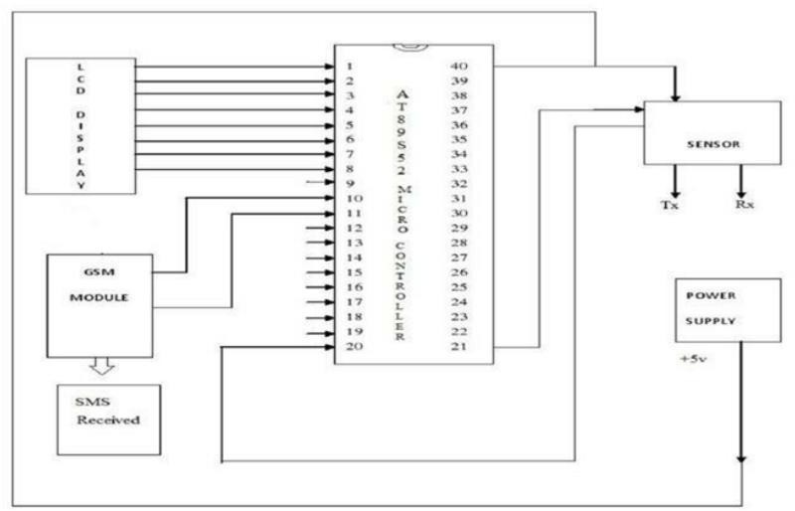



# PROBLEMS IDENTIFIED:

Air Pollution Detector

Fuel Theft Detection System Smart street lights

# Root cause of the problem

In our Country major problem we are facing is that there in hike in petrol and diesel and upon that stealing of fuel is seen a lot in parking area or on road side area, by which we are unable to find the fuel level droping so to overcome this we have introduced a fuel theft detection system.

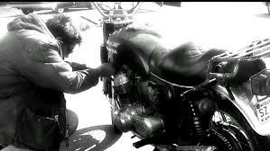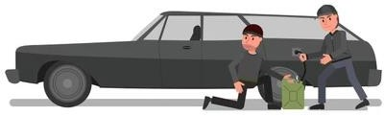

FUEL THEFT FROM BIKE FUEL THEFT FROM BIKE



# CHAPTER 2

## LITERATURE REVIEW

Our team has searched for many problems and came to conclusion that the major problem Now-a- days the people are facing is robbing of the fuel, so we have built a device which helps us continuously monitoring the vehicle’s fuel when it is turned.

By this when a person tries to rob the fuel when it is in parking area, the alarm comes from the vehicle and as well as the notification is sent to the owner of the vehicle.

## Existing solutions

Now there are three main methods used for providing security to automobiles.

They are electronic immobilizer, vehicle tracking system and car alarm. But the costs of manufacturing these systems are quite high when comparing to the proposed system. And we can easily deactivate the warning alarm present in car security system. In developing economies where the market for car is high the people are not able to get access to high cost security systems.

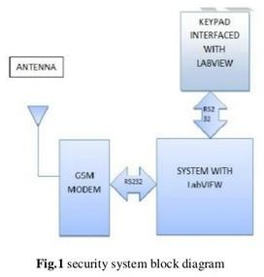



# CHAPTER 3

## METHODOLOGY

This project is completely depends on the code we write and the sensors we use. In the code, we write that when the sensor senses the property and the type of input it want, it displays the output on the console.

When a person is tried to steal fuel from the tank while engine is turned off then the alarm will be activated and buzzer makes sound and alarm will be sent to the person’s phone.

The digital meter follows a sequence. The functions are as follows:

1. Start
2. Initializing the switch of vehicle
3. Start the engine of the vehicle
4. Display the level of the fuel and gear on LCD
5. Keep the engine ON, and display current value of fuel level and gear level.
6. Stop the engine of the vehicle
7. Store the petrol level value
8. If the petrol level goes down from stored value during thefting.
9. Then send message to owner and buzzer of vehicle will ON
10. If not then go to step no 7
11. Stop



## PROBLEM STATEMENT

1. This project aims for developing and enhancement of the vehicle by setting up an indication system.
2. This project aims for developing and enhancement of the vehicle by setting.
3. In attempt of theft the system sends theft message to owner and at the same time starts up an alarm from the buzzer.
4. The safety of vehicle's fuel is extremely essential for public. Due to the excessive rate at which vehicle's fuel is being stolen in our country.
5. As per the circumstances, the hike in fuel prices are bothersome and this impact of fuel prices seem to have affected everyday spending habits as well.
6. With this design a vehicle can also be monitored irrespective of where it is parked.

## OBJECTIVE

* + - We consider this project as a boon to many people as it continuously helps in monitoring the fuel level when the engine is off.
    - This project replaces many devices as our device helps us in proving message, alarm and location.

## REQUIREMENT ANALYSIS

**Software requirements:** µ vision

**Hardware requirements:**

|  |  |  |  |
| --- | --- | --- | --- |
| 1.Fuel level sensor | 2.Power source | 3.ADC | 4.8051  microcontroller |
| 5.LCD display | 6.Buzzer | 7.GSM modem | 8.SIM |
| 9.Ignition lock | 10.Keys | 11.Cables and connectors | 12.Mobile |



## BLOCK DIAGRAM

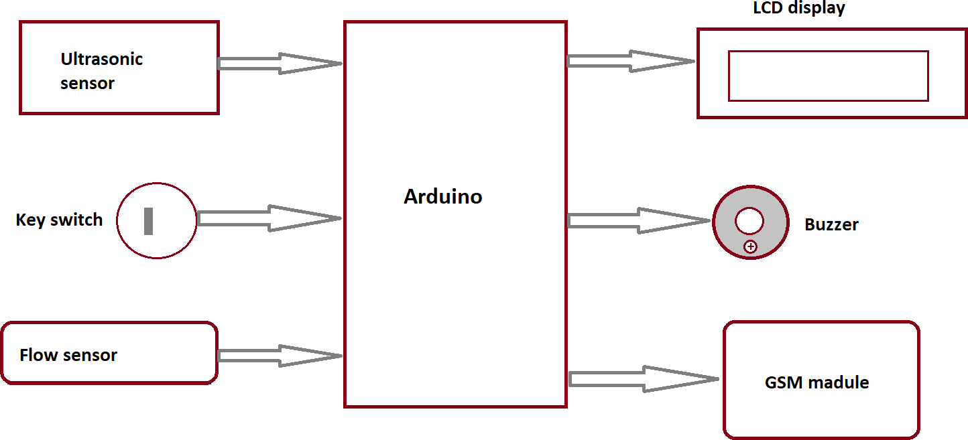

Fig 3.5: Block diagram



## Design description

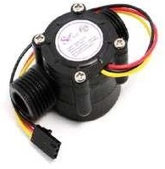

Fig. Ultrasonic sensor HC-SR04 Fig. Flow Sensor

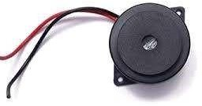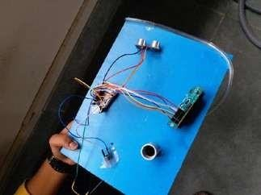

Fig.BUZZER Fig.Project kit

Fig 3.6: Product design



# CHAPTER 4

## RESULTS AND DISCUSSION:

This is designed in such a way that we can get accurate value of the fuel level and the readings of it.

A code with the required parameters of operation, including the range of detection of the sensor and the working of the buzzer is uploaded to the arduino uno.

Three sensor are provided for detection of fuel level in the tank.

**Advantages:-**

* We can get the accurate fuel value presented in the fuel tank in digits or number.
* This system can applicable for all the type of vehicles like car, bike etc.
* This project is trouble-free to utilise.
* This system is fully automated and it does not require any human attention**.**

## Pros

Cost efficient Easy to use Process is faster

Gaining accurate results

## Cons

It need to be cleaned to avoid rusting.

When the vehicle suddenly stops, it sends notification.



# CHAPTER 5

## CONCLUSION

The proposed method works efficiently in fuel monitoring in fuel stations and theft detection. This also provides real-time data with in time on web portal and android application. By this system the thefts can be detected at parking places and also the at bunks. This proposed system could help us solve these two problems.

## REFERENCES

1. ETSI(European telecommunication standards institute),GTS-GSM Technical Specification Version 5 Jan. 1995.
2. ETSI(European telecommunication standards institute),GTS-GSM, ”short message service cell broadcast (SMSCB) support on the mobile radio interface”,vol.5,no.1,pp 443-489,July 1996.
3. Telecommunication Industry Association “sms” TIA/EIA-637-A,Dec 1999.
4. The term”crystal oscillator”refers to circuit not the circuit,not the resonator:gaf,ruodolff.(1999)
5. Goodman, D.J., “Trends in cellular and cordless communications”, IEEE Communications Magazine, Volume: